Ex.N.3: Spectrum Analysis of Sub-1 GHz, Mid-band & mmWave by Plotting Propagation Loss.

Objective :
1. To compute the Propagation Loss (dB) for Sub-1 GHz, Mid-band, and mmWave
frequency ranges using standard path loss models.
2. To evaluate the impact of different Operating Frequencies (GHz) on signal attenuation
and coverage performance.
3. To analyze how Communication Distance (km) affects propagation loss across
different spectrum bands.

Objective 1: Matlab Code and Output:
clc; clear; close all;
d = 0.1:0.1:5; % Distance (km)
f = [900 3500 28000]; % Frequency (MHz)
PL1 = 32.44 + 20*log10(f(1)) + 20*log10(d);
PL2 = 32.44 + 20*log10(f(2)) + 20*log10(d);
PL3 = 32.44 + 20*log10(f(3)) + 20*log10(d);
figure
% -------- Graph 1 --------
subplot(2,1,1)
plot(d,PL1,'b','LineWidth',2); hold on
plot(d,PL2,'r','LineWidth',2)
plot(d,PL3,'k','LineWidth',2)
title('Propagation Loss vs Distance')
xlabel('Distance (km)')
ylabel('Loss (dB)')
grid on
% -------- Graph 2 (NO legend used to avoid error) --------
subplot(2,1,2)
Freq = [900 3500 28000];
Loss = [PL1(10) PL2(10) PL3(10)];
plot(Freq,Loss,'-o','LineWidth',2)
title('Propagation Loss vs Frequency')
xlabel('Frequency (MHz)')
ylabel('Loss (dB)')
grid on
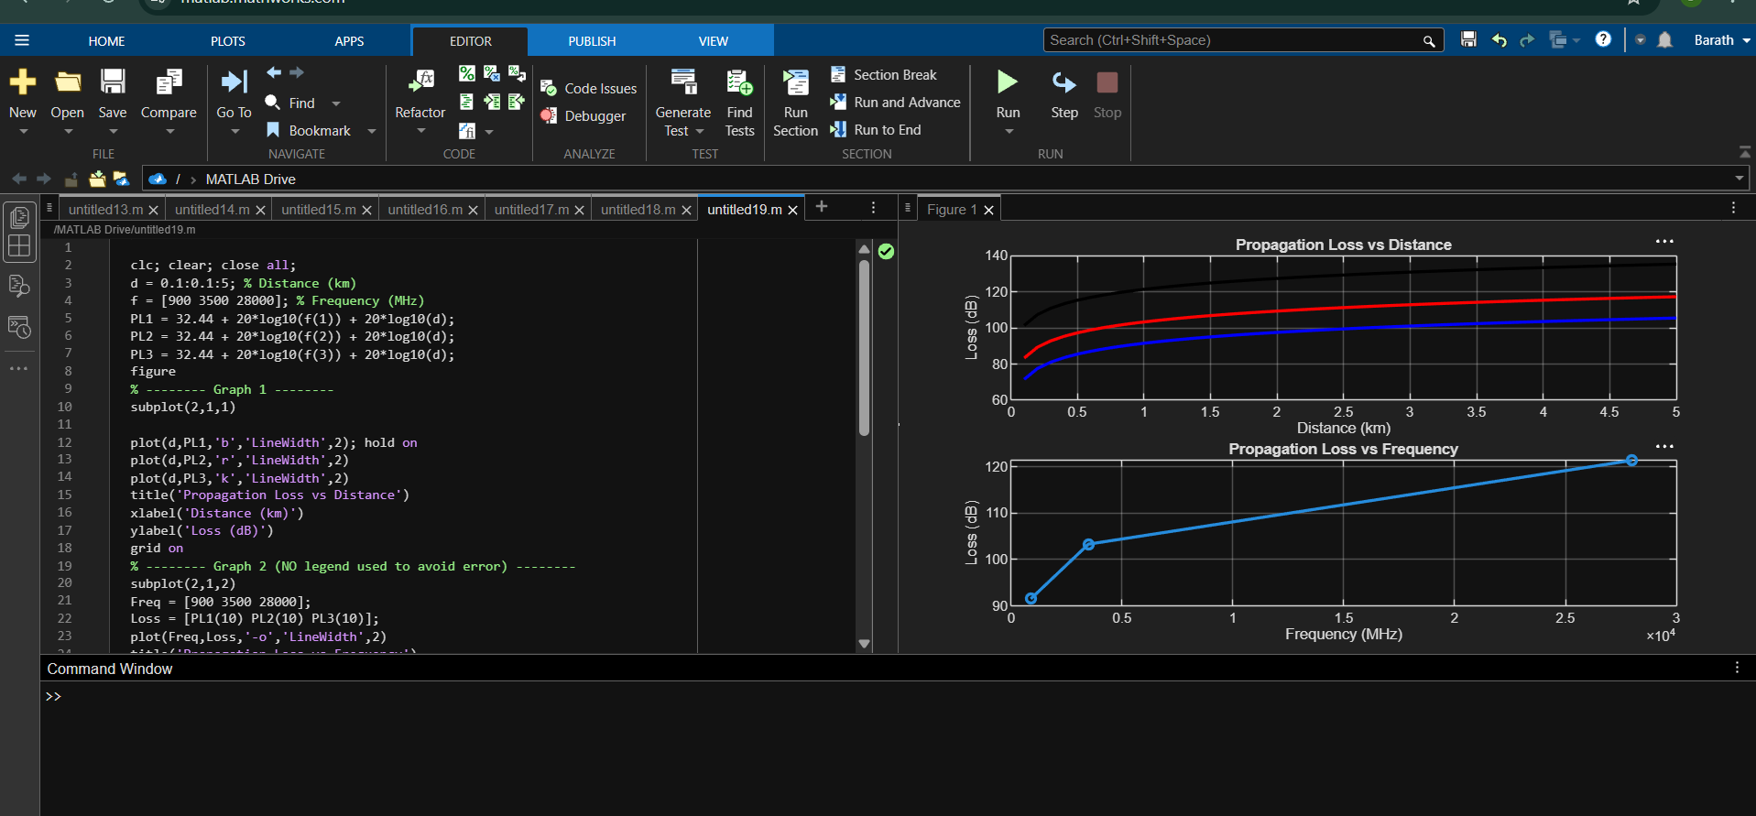

Objective 2: Matlab Code and Output:
clc; clear; close all;
d = 2; % fixed distance (km)
f = [900 3500 28000]; % MHz
PL = 32.44 + 20*log10(f) + 20*log10(d);
figure
% -------- Graph 1: Frequency vs Loss --------
subplot(2,1,1)
plot(f,PL,'-o','LineWidth',2)
title('Propagation Loss vs Operating Frequency')
xlabel('Frequency (MHz)')
ylabel('Propagation Loss (dB)')
grid on
% -------- Graph 2: Band Comparison --------
subplot(2,1,2)
bar(PL)
title('Comparison of Propagation Loss Across Bands')
xlabel('Frequency Bands (Index: 1=Sub-1GHz, 2=Mid-band, 3=mmWave)')
ylabel('Propagation Loss (dB)')
xticklabels({'Sub-1GHz','Mid-band','mmWave'})
grid on
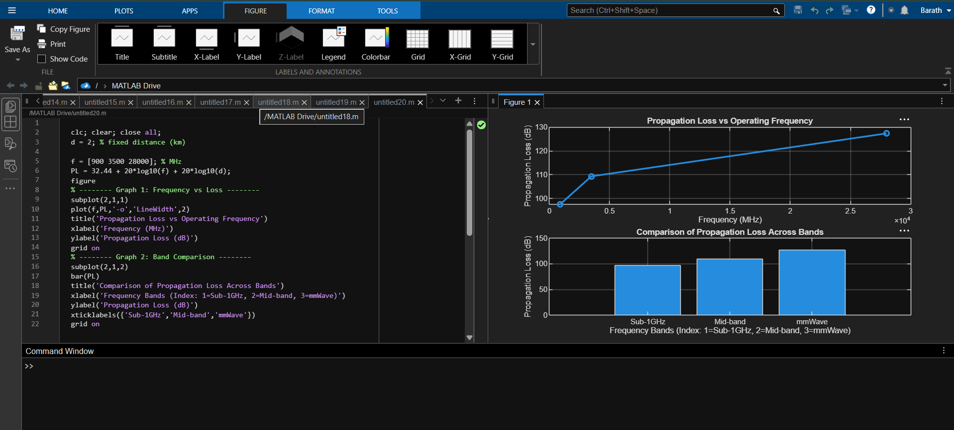

Objective 3: Matlab Code and Output:
clc; clear; close all;
% Frequency bands (MHz)
f = [900 3500 28000];
% Distance (km)
d = 2;
% Propagation Loss (FSPL)
PL = 32.44 + 20*log10(f) + 20*log10(d);
figure
% -------- Graph 1: Simple Line Plot (SAFE) --------
subplot(2,1,1)
plot(f, PL, '-o', 'LineWidth', 2)
title('Propagation Loss vs Operating Frequency')
xlabel('Frequency (MHz)')
ylabel('Propagation Loss (dB)')
grid on
% -------- Graph 2: Safe Comparison Plot --------
subplot(2,1,2)
plot(1:3, PL, '-s', 'LineWidth', 2)
title('Band-wise Propagation Loss Comparison')
xlabel('Band Index (1=Sub1GHz, 2=Mid-band, 3=mmWave)')
ylabel('Propagation Loss (dB)')
grid on
